**VISVESVARAYA TECHNOLOGICAL UNIVERSITY**

Jnana Sangama, Machhe, Belagavi, Karnataka 590018



MOBILE APPLICATION DEVELOPMENT MINI-PROJECT REPORT (18CSMP68)

On

**BMI CALCULATOR – ­­ANDROID APPLICATION**

*Submitted in partial fulfillment of the requirement*

*for the award of the degree of*

**Bachelor of Engineering**

in

# **Information Science & Engineering**

by

**Anish Kumar (1BG20IS008)**

**Piyush Kumar (1BG20IS034)**

**Tushar Prakash (1BG20IS060)**



**B.N.M. Institute of Technology**

**An Autonomous Institution under VTU, Approved by AICTE**

**Department of Information Science and Engineering**

**2022 – 2023**

**VISVESVARAYA TECHNOLOGICAL UNIVERSITY**

Jnana Sangama, Machhe, Belagavi, Karnataka 590018



MOBILE APPLICATION DEVELOPMENT MINI-PROJECT REPORT (18CSMP68)

On

**BMI CALCULATOR – ­­ANDROID APPLICATION**

*Submitted in partial fulfillment of the requirement*

*for the award of the degree of*

**Bachelor of Engineering**

in

# **Information Science & Engineering**

by

**Anish Kumar (1BG20IS008)**



**B.N.M. Institute of Technology**

**An Autonomous Institution under VTU, Approved by AICTE**

**Department of Information Science and Engineering**

**2022 – 2023**

**VISVESVARAYA TECHNOLOGICAL UNIVERSITY**

Jnana Sangama, Machhe, Belagavi, Karnataka 590018



MOBILE APPLICATION DEVELOPMENT MINI-PROJECT REPORT (18CSMP68)

On

**BMI CALCULATOR – ­­ANDROID APPLICATION**

*Submitted in partial fulfillment of the requirement*

*for the award of the degree of*

**Bachelor of Engineering**

in

# **Information Science & Engineering**

by

**Piyush Singh (1BG20IS034)**



**B.N.M. Institute of Technology**

**An Autonomous Institution under VTU, Approved by AICTE**

**Department of Information Science and Engineering**

**2022 – 2023**

**VISVESVARAYA TECHNOLOGICAL UNIVERSITY**

Jnana Sangama, Machhe, Belagavi, Karnataka 590018



MOBILE APPLICATION DEVELOPMENT MINI-PROJECT REPORT (18CSMP68)

On

**BMI CALCULATOR – ­­ANDROID APPLICATION**

*Submitted in partial fulfillment of the requirement*

*for the award of the degree of*

**Bachelor of Engineering**

in

# **Information Science & Engineering**

by

**Tushar Prakash (1BG20IS060)**



**B.N.M. Institute of Technology**

**An Autonomous Institution under VTU, Approved by AICTE**

**Department of Information Science and Engineering**

**2022 – 2023**

**B.N.M. Institute of Technology**

**An Autonomous Institution under VTU**

**DEPARTMENT OF INFORMATION SCIENCE & ENGINEERING**



**CERTIFICATE**

Certified that the Mini-project entitled **Bmi Calulator – Android Application** is carried out by **Mr.** **Anish Kumar** USN **1BG20IS008, Piyush Singh** USN **1BG20IS034, Tushar Prakash** USN **1BG20IS060** the bonafide student of **B.N.M Institute of Technology** in partial fulfillment for the award of **Bachelor of Engineering** in **Information Science & Engineering** of the **Visvesvaraya Technological University**, Belagavi during the year 2022-2023. It is certified that all corrections / suggestions indicated for Internal Assessment have been incorporated in the report deposited in the department library. The mini-project report has been approved as it satisfies the academic requirements in respect of mini-project prescribed for the said Degree.

|  |  |  |
| --- | --- | --- |
| Mrs. Divyashree S K  **Asst. Professor, Dept. of ISE**  BNMIT |  | Dr. S Srividhya  **Prof & Head, Dept. of ISE**  BNMIT |

## Name & Signature of the Examiners with date:

1.

2.

**B.N.M. Institute of Technology**

**An Autonomous Institution under VTU**

**DEPARTMENT OF INFORMATION SCIENCE & ENGINEERING**



**CERTIFICATE**

Certified that the Mini-project entitled **Bmi Calulator – Android Application** is carried out by Mr. **Anish Kumar** USN **1BG20IS008** the bonafide student of **B.N.M Institute of Technology** in partial fulfillment for the award of **Bachelor of Engineering** in **Information Science & Engineering** of the **Visvesvaraya Technological University**, Belagavi during the year 2022-2023. It is certified that all corrections / suggestions indicated for Internal Assessment have been incorporated in the report deposited in the department library. The mini-project report has been approved as it satisfies the academic requirements in respect of mini-project prescribed for the said Degree.

|  |  |  |
| --- | --- | --- |
| Mrs. Divyashree S K  **Asst. Professor, Dept. of ISE**  BNMIT |  | Dr. S Srividhya  **Prof & Head, Dept. of ISE**  BNMIT |

## Name & Signature of the Examiners with date:

1.

2.

**B.N.M. Institute of Technology**

**An Autonomous Institution under VTU**

**DEPARTMENT OF INFORMATION SCIENCE & ENGINEERING**



**CERTIFICATE**

Certified that the Mini-project entitled **Bmi Calulator – Android Application** is carried out by Mr. **Piyush Singh** USN **1BG20IS034** the bonafide student of **B.N.M Institute of Technology** in partial fulfillment for the award of **Bachelor of Engineering** in **Information Science & Engineering** of the **Visvesvaraya Technological University**, Belagavi during the year 2022-2023. It is certified that all corrections / suggestions indicated for Internal Assessment have been incorporated in the report deposited in the department library. The mini-project report has been approved as it satisfies the academic requirements in respect of mini-project prescribed for the said Degree.

|  |  |  |
| --- | --- | --- |
| Mrs. Divyashree S K  **Asst. Professor, Dept. of ISE**  BNMIT |  | Dr. S Srividhya  **Prof & Head, Dept. of ISE**  BNMIT |

## Name & Signature of the Examiners with date:

1.

2.

**B.N.M. Institute of Technology**

**An Autonomous Institution under VTU**

**DEPARTMENT OF INFORMATION SCIENCE & ENGINEERING**



**CERTIFICATE**

Certified that the Mini-project entitled **Bmi Calulator – Android Application** is carried out by Mr. **Tushar Prakash** USN **1BG20IS060** the bonafide student of **B.N.M Institute of Technology** in partial fulfillment for the award of **Bachelor of Engineering** in **Information Science & Engineering** of the **Visvesvaraya Technological University**, Belagavi during the year 2022-2023. It is certified that all corrections / suggestions indicated for Internal Assessment have been incorporated in the report deposited in the department library. The mini-project report has been approved as it satisfies the academic requirements in respect of mini-project prescribed for the said Degree.

|  |  |  |
| --- | --- | --- |
| Mrs. Divyashree S K  **Asst. Professor, Dept. of ISE**  BNMIT |  | Dr. S Srividhya  **Prof & Head, Dept. of ISE**  BNMIT |

## Name & Signature of the Examiners with date:

1.

2.

|  |  |  |
| --- | --- | --- |
| **Chapter No.** | **Title** | **Page No.** |
| **1** | **INTRODUCTION** | **1** |
| 1.1 | Objective | 1 |
| 1.2 | Scope of the project | 2 |
| 1.3 | Motivation | 2 |
| **2** | **METHODOLOGY** | **3** |
| 2.1 | Tools | 3 |
| 2.2 | Programming Languages | 4 |
| **3** | **SYSTEM REQUIREMENTS SPECIFICATION** | **5** |
| 3.1 | User Requirements | 5 |
| 3.2 | Software Requirements | 5 |
| 3.3 | Hardware Requirements | 6 |
| 3.4 | Functional Requirements | 6 |
| 3.5 | Non-Functional Requirements | 7 |
| **4** | **SYSTEM DESIGN AND DEVELOPMENT** | **8** |
| 4.1 | Architectural Design | 8 |
| **5** | **IMPLEMENTATION** | **9** |
| 5.1 | Algorithm | 9 |
| 5.2  5.3 | XML Code Snippet  Java Code Snippets | 10  21 |
| **6**  6.1  **7** | **RESULTS AND DISCUSSIONS**  Snapshots of the project  **CONCLUSION**  **REFERENCES**  **CERTIFICATES** | **28**  28  **33**  **34** |

|  |  |  |  |
| --- | --- | --- | --- |
| **Chapter No.** | **Figure No.** | **Description** | **Page No.** |
| 4 | Fig 4.1 | System Architecture | 8 |
| 6 | Fig 6.1 | Splash Screen | 28 |
|  | Fig 6.2 | Home Screen | 28 |
|  | Fig 6.3 | Landing Page Screen 1 | 29 |
|  | Fig 6.4 | Landing Page Screen 2 | 29 |
|  | Fig 6.5 | Landing Page Screen 3 | 30 |
|  | Fig 6.6  Fig 6.7  Fig 6.8 | Landing Page Screen 4  Landing Page Screen 5  Landing Page Screen 6 | 30  31  31 |
|  | Fig 6.9 | Landing Page Screen 7 | 32 |
|  | Fig 6.10 | Landing Page Screen 8 | 32 |
|  |  |  |  |

|  |  |  |  |
| --- | --- | --- | --- |
| **Chapter No.** | **Table No.** | **Description** | **Page No.** |
| 3 | 3.1 | Software Requirements | 5 |
|  | 3.2 | Hardware Requirements | 6 |

**CHAPTER 1**

**INTRODUCTION**

Android Studio is the official Integrated Development Environment (IDE) for Android app development, based on IntelliJ IDEA. On top of IntelliJ's powerful code editor and developer tools, Android Studio offers even more features that enhance your productivity when building Android apps, such as:

1) A flexible Gradle-based build system

2) A fast and feature-rich emulator

3) A unified environment where you can develop for all Android devices

4) Apply Changes to push code and resource changes to your running app without

restarting your app

5) Code templates and GitHub integration to help you build common app features and

import sample code

6) Extensive testing tools and frameworks

7) Lint tools to catch performance, usability, version compatibility, and other problems

8) C++ and NDK support

9) Built-in support for Google Cloud Platform, making it easy to integrate Google loud

Messaging and App Engine.

* 1. **Objective**

The objective of a BMI (Body Mass Index) calculator is to provide individuals with a numerical measure that indicates their body weight relative to their height. The calculator aims to assess weight status, identify potential health risks, monitor progress, and encourage individuals to take proactive steps towards achieving and maintaining a healthy weight. By calculating BMI, individuals can understand whether they are underweight, have a normal weight, are overweight, or fall into the obese category. This serves as a point of reference for evaluating weight status and determining the associated health risks. The calculator also allows individuals to track their weight changes over time, enabling them to monitor progress towards their weight management goals.

* 1. **Scope of the Project**

The scope of a BMI (Body Mass Index) calculator is to provide a convenient and accessible tool for individuals to assess their weight status and potential health risks associated with weight. The calculator aims to accommodate a wide range of users, from individuals who want to monitor their personal weight management progress to healthcare professionals who use it as a screening tool. While the calculator serves as a useful initial assessment tool, it is important to note that it has limitations and should be interpreted alongside other factors for a comprehensive evaluation of an individual's health and well-being.

* 1. **Motivation**

The motivation behind the development of a BMI (Body Mass Index) calculator lies in the need to provide individuals with a practical and informative tool for assessing their weight status and understanding potential health risks. The calculator aims to empower individuals to take control of their health by offering a simple and accessible means to evaluate their weight relative to their height. The calculator acts as a catalyst for behavior change, motivating individuals to adopt healthier habits and strive for a healthier weight.

Ultimately, the motivation behind the BMI calculator is to inspire individuals to take proactive steps towards achieving and maintaining a healthy weight, leading to improved overall well-being and reduced risks of weight-related health conditions.

**CHAPTER 2**

**METHODOLOGY**

The methodology for creating a news app using Android Studio typically begins with thorough planning and requirement gathering. This involves understanding the target audience, identifying the core features of the app, and outlining the overall user experience.

**2.1 TOOLS**

**Platform: Android Studio**

Android Studio is the official integrated development environment (IDE) for Google’s Android OS, built on JetBrains' IntelliJ IDEA software and designed specifically for Android development. It is available for download on Windows, macOS and Linux based operating systems or as a subscription-based service in 2020. It is a replacement for the Eclipse Android Development Tools (E-ADT) as the primary IDE for native Android application development.

Android Studio was announced on May 16, 2013 at the Google I/O conference. It was in early access preview stage starting from version 0.1 in May 2013, then entered beta stage starting from version 0.8 which was released in June 2014. The first stable build was released in December 2014, starting from version 1.0.

On May 7, 2019, Kotlin replaced Java as Google's preferred language for Android app development. Java is still supported, as is C++.

**Features of Android Studio**

A specific feature of the Android Studio is an absence of the possibility to switch autosave feature off. The following features are provided in the current stable version:

* Gradle-based build support
* Android-specific refactoring and quick fixes
* Lint tools to catch performance, usability, version compatibility and otherproblems
* ProGuard integration and app-signing capabilities
* Template-based wizards to create common Android designs and components
* A rich layout editor that allows users to drag-and-drop UI components, option to preview layouts on multiple screen configurations
* Support for building Android Wear apps
* Built-in support for Google Cloud Platform, enabling integration with Firebase Cloud Messaging (Earlier 'Google Cloud Messaging') and Google App Engine.
* Android Virtual Device (Emulator) to run and debug apps in the Android studio.

Android Studio supports all the same programming languages of IntelliJ.e.g. Java, C++, and more with extensions, such as Go; and Android Studio 3.0 or later supports Kotlin and "all Java 7 language features and a subset of Java 8 language features that vary by platform version." External projects back port some Java 9 features. While IntelliJ states that Android Studio supports all released Java versions, and Java 12, it's not clear to what level Android Studio supports Java versions up to Java 12 (the documentation mentions partial Java 8 support). At least some new language features up to Java 12 are usable in Android.

Once an app has been compiled with Android Studio, it can be published on the Google Play Store. The application has to be in line with the Google Play Store developer content policy. The Android Emulator has additional requirements beyond the basic system requirements for Android Studio, which are described below:

* SDK Tools 26.1.1 or higher.
* 64-bit processor.
* Windows: CPU with UG (unrestricted guest) support;
* Intel Hardware Accelerated Execution Manager (HAXM) 6.2.1 or later (HAXM 7.2.0 or later recommended).

**2.2 Programming Language:**

**JAVA**

Java is a high-level, class-based, object-oriented programming language that is designed to have as few implementation dependencies as possible. It is a general- purpose programming language intended to let application developers write once, run anywhere (WORA), meaning that compiled Java code can run on all platforms that support Java without the need for recompilation. Java applications are typically compiled to byte-code that can run on any Java virtual machine (JVM) regardless of the underlying computer architecture. The syntax of Java is similar to C and C++, but has fewer low-level facilities than either of them. The Java runtime provides dynamic capabilities (such as reflection and runtime code modification) that are typically not available in traditional compiled languages

**CHAPTER 3**

**SYSTEM REQUIREMENT AND SPECIFICATION**

The System Requirements Specification for a news app developed using Android Studio involves outlining the necessary hardware and software components for the application to function properly.

**3.1 User Requirements**

When the app opens the user should be able to see their notes on the main page. They should be able to add/remove/archive their notes. An option is provided to add text/video/audio to their notes. The user should be able to categorize their notes and tag them and view the notes by category. The user can also make To-Do Lists and set timers and reminders for them. The user should also be able to share their notes with others. The user should be able to sort their notes according to date of creation, title of the note, etc.

**3.2 Software Requirements**

|  |  |  |  |
| --- | --- | --- | --- |
|  | **Microsoft Windows** | **Mac** | **Linux** |
| **Operating System Version** | Microsoft® | Mac® OS X® | GNOME or KDE |
| Windows® 7/8/10 | 10.10 (Yosemite) | desktop |
| (32- or 64-bit)  *The Android Emulator only supports 64-bit Windows.* | or higher, up to 10.14  (macOS Mojave) | *Tested on gLinux based on Debian (4.19.67-2rodete2).* |
| **Minimum required JDK version** | Java Development Kit 8 | | |
| **Android Studio** | Latest Version Available | | |

**Table 3.1 Software Requirements**

**3.3 Hardware Requirements**

|  |  |
| --- | --- |
| **Random Access Memory (RAM)** | 4 GB RAM minimum; 8 GB RAM recommended. |
| **Processor** | Intel® Core™ i5-8265U CPU @ 1.60GHz 1.80 GHz |
| **Free digital storage** | 2 GB of available digital storage minimum, 4 GB Recommended (500 MB for IDE + 1.5 GB for Android SDK and emulator system image). |
| **Minimum screen resolution** | 1280 x 800 |
| **System Type** | 64-bit Operating System, x64-bases processor |

**Table 3.2 Hardware Requirements**

**3.4 Functional Requirements**

* Input Validation: The calculator should validate user input for height and weight to ensure they are within acceptable ranges. It should handle various units of measurement (e.g., centimeters, inches, kilograms, pounds) and convert them to a standardized format.
* BMI Calculation: The calculator should accurately calculate the BMI based on the user's height and weight input. The BMI formula used should be appropriate for the selected unit system (e.g., metric or imperial).
* Weight Classification: The calculator should determine the weight classification based on the calculated BMI value. It should categorize individuals as underweight, normal weight, overweight, or obese according to standard thresholds.
* Display of Results: The calculator should display the calculated BMI value and weight classification to the user in a clear and understandable format. It should also provide a brief explanation of what the BMI value means in terms of weight status.
* Mobile Responsiveness: If the BMI calculator is designed for a mobile application or responsive web design, it should be optimized for different mobile devices.

**3.5 Non-Functional Requirements**

* Accuracy: The calculator should provide accurate BMI calculations to ensure reliable weight status assessment. It should adhere to standard BMI formulas and calculations recommended by authoritative sources.
* Performance: The calculator should be designed to provide fast and responsive results, even with a large number of user calculations or concurrent users. It should handle calculations efficiently to minimize any delays or sluggishness.
* Usability: The calculator should have a user-friendly interface that is easy to navigate and understand. It should provide clear instructions, error messages, and feedback to guide users through the process. The layout and design should be intuitive and visually appealing.
* Accessibility: The calculator should be accessible to users with disabilities. It should follow accessibility guidelines, such as providing alternative text for images, ensuring proper color contrast, and supporting keyboard navigation.
* Compatibility: The calculator should be compatible with different web browsers and operating systems to ensure broad accessibility. It should be tested and validated on popular platforms to ensure consistent performance and user experience.

**CHAPTER 4**

**SYSTEM DESIGN AND DEVELOPMENT**

Designing and developing a news app using Android Studio involves several key steps and considerations. The overall goal is to create a user-friendly and engaging application that delivers up-to-date news content efficiently.

**4.1 System Architecture**

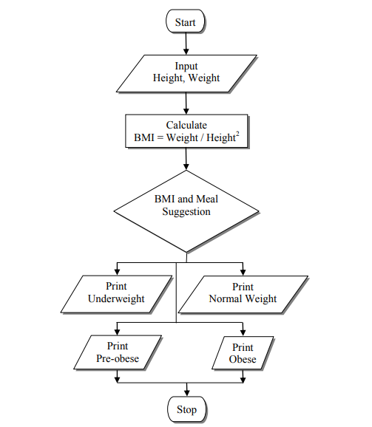

**Fig 4.1** Data flow Diagram for BMI Calculator

In the above Fig. 4.1, BMI Calculator also developed for meal suggestions on the application utilizing App. The suggestions for breakfast, lunch, and dinner are based on the number of body mass needed by the user, Calculator Android Application. Then, the third stage of BMI Calculator application development (Coding) was the implementation stage. Testing was performed concurrently with the programming of the application. Two inputs are demanded from the users which are height and weight.

**CHAPTER 5**

**IMPLEMENTATION**

**5.1 Algorithm**

* Start the BMI calculator program.
* Display a welcome message and prompt the user to enter their height and weight.
* Validate the user inputs to ensure they are numeric and within acceptable ranges.
* Calculate the BMI using the formula: BMI = weight / (height^2), where weight is in kilograms and height is in meters. If the inputs are in different units, convert them to the appropriate units before performing the calculation.
* Determine the weight classification based on the calculated BMI. Use predefined thresholds to categorize the BMI value into underweight, normal weight, overweight, or obese.
* Display the calculated BMI and weight classification to the user.
* Based on the weight classification, recommend an appropriate diet plan to the user. This could be a general recommendation or personalized based on specific weight goals or dietary restrictions.
* Display the recommended diet plan to the user.
* End the program.

**5.2 XML Code Snippet**

**Activity_splash.xml:-**

<?xml version="1.0" encoding="utf-8"?>

<RelativeLayout xmlns:android="http://schemas.android.com/apk/res/android"

xmlns:app="http://schemas.android.com/apk/res-auto"

xmlns:tools="http://schemas.android.com/tools"

android:layout_width="match_parent"

android:layout_height="match_parent"

android:background="#2c2c2c"

tools:context=".splash">

<ImageView

android:layout_width="100dp"

android:layout_height="100dp"

android:src="@drawable/bmifinall"

android:layout_centerInParent="true"

android:id="@+id/logo">

</ImageView>

<TextView

android:layout_width="wrap_content"

android:layout_height="wrap_content"

android:layout_centerHorizontal="true"

android:text="BMI CALCULATOR"

android:layout_marginTop="30dp"

android:textStyle="bold"

android:fontFamily="@font/raleway"

android:textSize="20sp"

android:layout_below="@id/logo"

android:textColor="@color/white"

android:lineSpacingExtra="2dp">

</TextView>

</RelativeLayout>  
 android:orientation="vertical" />  
  
 </androidx.drawerlayout.widget.DrawerLayout>  
  
</FrameLayout>

**Activity_diet.xml:-**

<?xml version="1.0" encoding="utf-8"?>

<RelativeLayout xmlns:android="http://schemas.android.com/apk/res/android"

xmlns:app="http://schemas.android.com/apk/res-auto"

xmlns:tools="http://schemas.android.com/tools"

android:layout_width="match_parent"

android:layout_height="match_parent"

android:id="@+id/background"

android:background="#1E1D1D"

tools:context=".bmiactivity">

<ImageView

android:layout_width="wrap_content"

android:layout_height="wrap_content"

android:padding="10dp"

android:id="@+id/imageview"

android:layout_above="@id/contentlayout"

android:layout_marginBottom="30dp"

android:layout_centerHorizontal="true"

android:src="@drawable/ok">

</ImageView>

<RelativeLayout

android:id="@+id/contentlayout"

android:layout_width="match_parent"

android:layout_height="wrap_content"

android:layout_centerInParent="true"

android:background="@drawable/cardbackgroung"

android:padding="20dp">

<TextView

android:id="@+id/genderdisplay"

android:layout_width="wrap_content"

android:layout_height="wrap_content"

android:layout_alignParentStart="true"

android:layout_marginStart="19dp"

android:layout_marginTop="15dp"

android:text="Healthy Foods That Can Help You"

android:textColor="@color/white"

android:textSize="17sp"

android:textStyle="bold" />

<TextView

android:id="@+id/food"

android:layout_width="wrap_content"

android:layout_height="wrap_content"

android:layout_below="@id/genderdisplay"

android:layout_centerHorizontal="true"

android:layout_marginTop="15dp"

android:fontFamily="@font/raleway"

android:text=""

android:textColor="@color/white"

android:textSize="25sp"

android:textStyle="bold">

</TextView>

</RelativeLayout>

<android.widget.Button

android:id="@+id/gotomain"

android:layout_width="match_parent"

android:layout_height="48dp"

android:layout_below="@id/contentlayout"

android:layout_centerHorizontal="true"

android:layout_marginLeft="20dp"

android:layout_marginTop="97dp"

android:layout_marginRight="20dp"

android:background="@drawable/buttonbackground"

android:fontFamily="@font/raleway"

android:text="RECALCULATE YOUR BMI"

android:textColor="@color/white"

android:textSize="15sp"

android:textStyle="bold">

</android.widget.Button>

</RelativeLayout>

**Activity_bmiactivity.xml:-**

<? xml version="1.0" encoding="utf-8"?>

<RelativeLayout xmlns:android="http://schemas.android.com/apk/res/android"

xmlns:app="http://schemas.android.com/apk/res-auto"

xmlns:tools="http://schemas.android.com/tools"

android:layout_width="match_parent"

android:layout_height="match_parent"

android:id="@+id/background"

android:background="#1E1D1D"

tools:context=".bmiactivity">

<android.widget.Button

android:id="@+id/gotomain2"

android:layout_width="match_parent"

android:layout_height="40dp"

android:layout_below="@id/contentlayout"

android:layout_centerHorizontal="true"

android:layout_marginLeft="20dp"

android:layout_marginTop="136dp"

android:layout_marginRight="20dp"

android:background="@drawable/buttonbackground"

android:fontFamily="@font/raleway"

android:text="Suggest Diet"

android:textColor="@color/white"

android:textSize="15sp"

android:textStyle="bold">

</android.widget.Button>

<ImageView

android:layout_width="wrap_content"

android:layout_height="wrap_content"

android:padding="10dp"

android:id="@+id/imageview"

android:layout_above="@id/contentlayout"

android:layout_marginBottom="30dp"

android:layout_centerHorizontal="true"

android:src="@drawable/ok">

</ImageView>

<RelativeLayout

android:layout_width="match_parent"

android:layout_height="wrap_content"

android:padding="20dp"

android:id="@+id/contentlayout"

android:background="@drawable/cardbackgroung"

android:layout_centerInParent="true">

<TextView

android:layout_width="wrap_content"

android:layout_height="wrap_content"

android:textSize="50sp"

android:textStyle="bold"

android:layout_centerHorizontal="true"

android:background="@color/trans"

android:textColor="@color/white"

android:id="@+id/bmidisplay"

android:text="22">

</TextView>

<TextView

android:layout_width="wrap_content"

android:layout_height="wrap_content"

android:text="Gender"

android:layout_marginTop="15dp"

android:textSize="17sp"

android:textStyle="bold"

android:layout_below="@id/bmidisplay"

android:layout_centerHorizontal="true"

android:textColor="@color/white"

android:id="@+id/genderdisplay" />

<TextView

android:layout_width="wrap_content"

android:layout_height="wrap_content"

android:text="Your BMI Category Is"

android:textStyle="bold"

android:id="@+id/bmicategorydispaly"

android:textColor="@color/white"

android:fontFamily="@font/raleway"

android:layout_marginTop="15dp"

android:layout_centerHorizontal="true"

android:layout_below="@id/genderdisplay"

android:textSize="25sp">

</TextView>

</RelativeLayout>

**Activity_main.xml:-**

<?xml version="1.0" encoding="utf-8"?>

<RelativeLayout xmlns:android="http://schemas.android.com/apk/res/android"

xmlns:tools="http://schemas.android.com/tools"

android:layout_width="match_parent"

android:layout_height="match_parent"

android:background="#1E1D1D"

tools:context=".MainActivity">

<RelativeLayout

android:layout_width="match_parent"

android:layout_height="wrap_content"

android:id="@+id/centerhorizontalline"

android:layout_centerInParent="true">

</RelativeLayout>

<RelativeLayout

android:layout_width="wrap_content"

android:layout_height="match_parent"

android:layout_centerInParent="true"

android:id="@+id/centerverticalline">

</RelativeLayout>

<RelativeLayout

android:layout_width="150dp"

android:layout_height="150dp"

android:layout_toStartOf="@id/centerverticalline"

android:background="@drawable/cardbackgroung"

android:layout_above="@id/heightlayout"

android:layout_marginBottom="35dp"

android:layout_marginRight="20dp"

android:layout_marginLeft="20dp"

android:id="@+id/male">

<ImageView

android:layout_width="170px"

android:layout_height="170px"

android:layout_above="@id/textmale"

android:layout_marginBottom="20dp"

android:layout_centerInParent="true"

android:src="@drawable/male"

android:contentDescription="@string/todo">

</ImageView>

<TextView

android:layout_width="match_parent"

android:layout_height="wrap_content"

android:textSize="18sp"

android:textColor="@color/white"

android:text="@string/male"

android:id="@+id/textmale"

android:textStyle="bold"

android:fontFamily="@font/raleway"

android:textAlignment="center"

android:layout_alignParentBottom="true"

android:layout_marginBottom="10dp">

</TextView>

</RelativeLayout>

<RelativeLayout

android:layout_width="150dp"

android:layout_height="150dp"

android:layout_above="@id/heightlayout"

android:layout_marginBottom="35dp"

android:layout_marginRight="20dp"

android:layout_toEndOf="@id/centerverticalline"

android:background="@drawable/cardbackgroung"

android:layout_marginLeft="20dp"

android:id="@+id/female">

<ImageView

android:layout_width="170px"

android:layout_height="170px"

android:layout_centerInParent="true"

android:layout_above="@id/textfemale"

android:layout_marginBottom="20dp"

android:src="@drawable/female"

android:contentDescription="@string/todo">

</ImageView>

<TextView

android:layout_width="match_parent"

android:layout_height="wrap_content"

android:textSize="18sp"

android:textColor="@color/white"

android:text="@string/femaletext"

android:id="@+id/textfemale"

android:textStyle="bold"

android:fontFamily="@font/raleway"

android:textAlignment="center"

android:layout_alignParentBottom="true"

android:layout_marginBottom="10dp">

</TextView>

</RelativeLayout>

<RelativeLayout

android:layout_width="340dp"

android:layout_height="150dp"

android:layout_above="@id/centerhorizontalline"

android:layout_marginBottom="-50dp"

android:layout_centerHorizontal="true"

android:background="@drawable/cardbackgroung"

android:layout_marginLeft="25dp"

android:layout_marginRight="25dp"

android:id="@+id/heightlayout">

<TextView

android:layout_width="match_parent"

android:layout_marginTop="15dp"

android:textAlignment="center"

android:textStyle="bold"

android:fontFamily="@font/raleway"

android:layout_height="wrap_content"

android:textColor="@color/white"

android:text="@string/height"

android:textSize="20sp">

</TextView>

<TextView

android:layout_width="wrap_content"

android:layout_height="wrap_content"

android:text="@string/startingheight"

android:layout_marginBottom="50dp"

android:textSize="40sp"

android:layout_alignParentBottom="true"

android:textColor="@color/white"

android:layout_centerInParent="true"

android:id="@+id/currentheight"

android:textStyle="bold">

</TextView>

<TextView

android:layout_width="wrap_content"

android:layout_height="wrap_content"

android:text="@string/unit"

android:textSize="20sp"

android:fontFamily="@font/raleway"

android:textStyle="bold"

android:layout_toEndOf="@id/currentheight"

android:layout_marginStart="20dp"

android:layout_centerInParent="true"

android:textColor="@color/white" />

<SeekBar

android:layout_width="match_parent"

android:layout_height="wrap_content"

android:layout_alignParentBottom="true"

android:layout_marginBottom="20dp"

android:layout_marginLeft="10dp"

android:progressTint="#FF4C4C"

android:thumbTint="@color/white"

android:layout_marginRight="10dp"

android:id="@+id/seekbarforheight">

</SeekBar>

</RelativeLayout>

<android.widget.Button

android:layout_width="match_parent"

android:layout_height="40dp"

android:id="@+id/calculatebmi"

android:layout_alignParentBottom="true"

android:layout_marginBottom="15dp"

android:background="@drawable/buttonbackground"

android:text="@string/calculate_your_bmi"

android:textSize="15sp"

android:textColor="@color/white"

android:fontFamily="@font/raleway"

android:textStyle="bold"

android:layout_marginLeft="20dp"

android:layout_marginRight="20dp">

</android.widget.Button>

<RelativeLayout

android:layout_width="150dp"

android:layout_height="150dp"

android:layout_toStartOf="@id/centerverticalline"

android:background="@drawable/cardbackgroung"

android:layout_below="@id/heightlayout"

android:layout_marginBottom="20dp"

android:layout_marginTop="85dp"

android:layout_marginLeft="20dp"

android:layout_marginRight="20dp"

android:id="@+id/weight">

<TextView

android:layout_width="match_parent"

android:layout_height="wrap_content"

android:textSize="18sp"

android:textColor="@color/white"

android:text="@string/weight"

android:fontFamily="@font/raleway"

android:id="@+id/textweight"

android:layout_marginTop="15dp"

android:textAlignment="center"

android:textStyle="bold"

android:layout_marginBottom="10dp">

</TextView>

<TextView

android:id="@+id/currentweight"

android:layout_width="match_parent"

android:layout_height="wrap_content"

android:layout_centerInParent="true"

android:fontFamily="@font/raleway"

android:text="@string/startingweight"

android:textAlignment="center"

android:textColor="@color/white"

android:textSize="30sp"

android:textStyle="bold">

</TextView>

<RelativeLayout

android:layout_width="wrap_content"

android:layout_height="wrap_content"

android:layout_alignParentBottom="true"

android:layout_marginBottom="10dp"

android:layout_marginStart="20dp"

android:background="@drawable/plusminus"

>

<ImageView

android:layout_width="30dp"

android:layout_height="30dp"

android:src="@drawable/minus"

android:id="@+id/decrementweight"

android:contentDescription="@string/todo">

</ImageView>

</RelativeLayout>

<RelativeLayout

android:layout_width="wrap_content"

android:layout_height="wrap_content"

android:layout_alignParentBottom="true"

android:layout_marginBottom="10dp"

android:layout_marginEnd="20dp"

android:layout_alignParentEnd="true"

android:background="@drawable/plusminus">

<ImageView

android:layout_width="30dp"

android:layout_height="30dp"

android:id="@+id/incremetweight"

android:src="@drawable/add"

android:contentDescription="@string/todo">

</ImageView>

</RelativeLayout>

</RelativeLayout>

**5.4 Java Code Snippets:-**

**MainActivity.java:-**

package com.example.bmicalculator;

import androidx.appcompat.app.AppCompatActivity;

import androidx.core.content.ContextCompat;

import android.annotation.SuppressLint;

public class MainActivity extends AppCompatActivity {

TextView mcurrentheight;

TextView mcurrentweight,mcurrentage;

ImageView mincrementage,mdecrementage,mincrementweight,mdecrementweight;

SeekBar mseekbarforheight;

Button mcalculatebmi;

RelativeLayout mmale,mfemale;

int intweight=55;

int intage=22;

int currentprogress;

String mintprogress="170";

String typerofuser="0";

String weight2="55";

String age2="22";

@SuppressLint("ResourceAsColor")

@Override

protected void onCreate(Bundle savedInstanceState) {

super.onCreate(savedInstanceState);

setContentView(R.layout.activity_main);

mmale.setOnClickListener(new View.OnClickListener() {

@Override

public void onClick(View v) {

mmale.setBackground(ContextCompat.getDrawable(getApplicationContext(),R.drawable.malefemalefocus));

mfemale.setBackground(ContextCompat.getDrawable(getApplicationContext(),R.drawable.malefemalenotfocus));

typerofuser="Male";

}

});

mfemale.setOnClickListener(new View.OnClickListener() {

@Override

public void onClick(View v) {

mfemale.setBackground(ContextCompat.getDrawable(getApplicationContext(),R.drawable.malefemalefocus));

mmale.setBackground(ContextCompat.getDrawable(getApplicationContext(),R.drawable.malefemalenotfocus));

typerofuser="Female";

}

});

mseekbarforheight.setMax(300);

mseekbarforheight.setProgress(170);

mseekbarforheight.setOnSeekBarChangeListener(new SeekBar.OnSeekBarChangeListener() {

@Override

public void onProgressChanged(SeekBar seekBar, int progress, boolean fromUser) {

currentprogress=progress;

mintprogress=String.valueOf(currentprogress);

mcurrentheight.setText(mintprogress);

}

@Override

public void onStartTrackingTouch(SeekBar seekBar) {

}

@Override

public void onStopTrackingTouch(SeekBar seekBar) {

}

});

mincrementweight.setOnClickListener(new View.OnClickListener() {

@Override

public void onClick(View v) {

intweight=intweight+1;

weight2=String.valueOf(intweight);

mcurrentweight.setText(weight2);

}

});

mincrementage.setOnClickListener(new View.OnClickListener() {

@Override

public void onClick(View v) {

intage=intage+1;

age2=String.valueOf(intage);

mcurrentage.setText(age2);

}

});

mdecrementage.setOnClickListener(new View.OnClickListener() {

@Override

public void onClick(View v) {

intage=intage-1;

age2=String.valueOf(intage);

mcurrentage.setText(age2);

}

});

mdecrementweight.setOnClickListener(new View.OnClickListener() {

@Override

public void onClick(View v) {

intweight=intweight-1;

weight2=String.valueOf(intweight);

mcurrentweight.setText(weight2);

}

});

mcalculatebmi.setOnClickListener(new View.OnClickListener() {

@Override

public void onClick(View v) {

if(typerofuser.equals("0"))

{

Toast.makeText(getApplicationContext(),"Select Your Gender First",Toast.LENGTH_SHORT).show();

}

else if(mintprogress.equals("0"))

{

Toast.makeText(getApplicationContext(),"Select Your Height First",Toast.LENGTH_SHORT).show();

}

else if(intage==0 || intage<0)

{

Toast.makeText(getApplicationContext(),"Age is Incorrect",Toast.LENGTH_SHORT).show();

}

else if(intweight==0|| intweight<0)

{

Toast.makeText(getApplicationContext(),"Weight Is Incorrect",Toast.LENGTH_SHORT).show();

}

else {

Intent intent = new Intent(MainActivity.this, bmiactivity.class);

intent.putExtra("gender", typerofuser);

intent.putExtra("height", mintprogress);

intent.putExtra("weight", weight2);

intent.putExtra("age", age2);

startActivity(intent);

}

}

});

}

}

**Diet_page.java:-**

package com.example.bmicalculator;

import androidx.appcompat.app.AppCompatActivity;

import androidx.core.content.ContextCompat;

import android.annotation.SuppressLint;

import android.content.Intent;

import android.os.Bundle;

import android.view.View;

public class MainActivity extends AppCompatActivity {

TextView mcurrentheight;

TextView mcurrentweight,mcurrentage;

ImageView mincrementage,mdecrementage,mincrementweight,mdecrementweight;

SeekBar mseekbarforheight;

Button mcalculatebmi;

RelativeLayout mmale,mfemale;

int intweight=55;

int intage=22;

int currentprogress;

String mintprogress="170";

String typerofuser="0";

String weight2="55";

String age2="22";

@SuppressLint("ResourceAsColor")

@Override

protected void onCreate(Bundle savedInstanceState) {

super.onCreate(savedInstanceState);

setContentView(R.layout.activity_main);

getSupportActionBar().hide();

mcurrentage=findViewById(R.id.currentage);

mcurrentweight=findViewById(R.id.currentweight);

mcurrentheight=findViewById(R.id.currentheight);

mincrementage=findViewById(R.id.incrementage);

mdecrementage=findViewById(R.id.decrementage);

mincrementweight=findViewById(R.id.incremetweight);

mdecrementweight=findViewById(R.id.decrementweight);

mcalculatebmi=findViewById(R.id.calculatebmi);

mseekbarforheight=findViewById(R.id.seekbarforheight);

mmale=findViewById(R.id.male);

mfemale=findViewById(R.id.female);

mmale.setOnClickListener(new View.OnClickListener() {

@Override

public void onClick(View v) {

mmale.setBackground(ContextCompat.getDrawable(getApplicationContext(),R.drawable.malefemalefocus)); mfemale.setBackground(ContextCompat.getDrawable(getApplicationContext(),R.drawable.malefemalenotfocus));

typerofuser="Male";

}

});

mfemale.setOnClickListener(new View.OnClickListener() {

@Override

public void onClick(View v) {

mfemale.setBackground(ContextCompat.getDrawable(getApplicationContext(),R.drawable.malefemalefocus));

mmale.setBackground(ContextCompat.getDrawable(getApplicationContext(),R.drawable.malefemalenotfocus));

typerofuser="Female";

}

});

mseekbarforheight.setMax(300);

mseekbarforheight.setProgress(170);

mseekbarforheight.setOnSeekBarChangeListener(new SeekBar.OnSeekBarChangeListener() {

@Override

public void onProgressChanged(SeekBar seekBar, int progress, boolean fromUser) {

currentprogress=progress;

mintprogress=String.valueOf(currentprogress);

mcurrentheight.setText(mintprogress);

}

@Override

public void onStartTrackingTouch(SeekBar seekBar) {

}

@Override

public void onStopTrackingTouch(SeekBar seekBar) {

}

});

mincrementweight.setOnClickListener(new View.OnClickListener() {

@Override

public void onClick(View v) {

intweight=intweight+1;

weight2=String.valueOf(intweight);

mcurrentweight.setText(weight2);

}

});

mincrementage.setOnClickListener(new View.OnClickListener() {

@Override

public void onClick(View v) {

intage=intage+1;

age2=String.valueOf(intage);

mcurrentage.setText(age2);

}

});

mdecrementage.setOnClickListener(new View.OnClickListener() {

@Override

public void onClick(View v) {

intage=intage-1;

age2=String.valueOf(intage);

mcurrentage.setText(age2);

}

});

**CHAPTER 6**

**RESULTS AND DISCUSSIONS**

**6.1 Snapshots of the project**

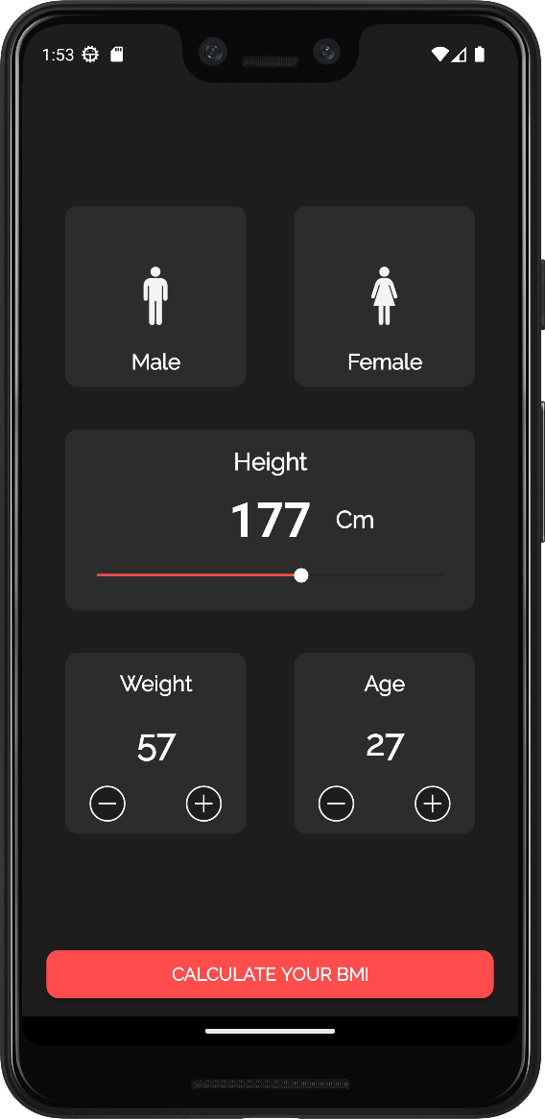

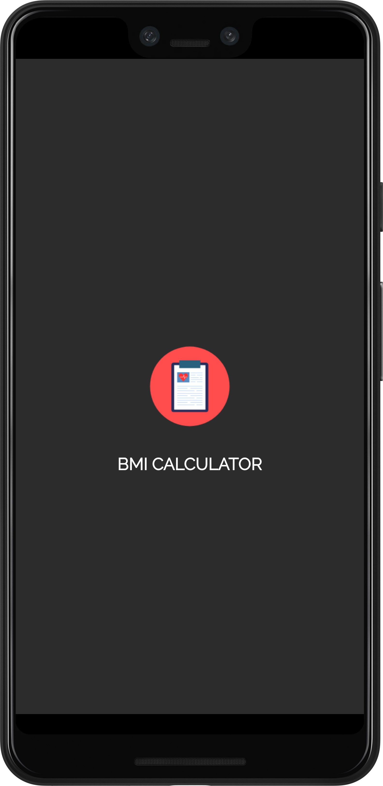

**Fig 6.1: Splash Screen Fig 6.2: Home Screen**

Fig 6.1 refers to splash screen when user open application .Fig 6.2 refers to home screen when user see the interface to give the inputs according to their preferences

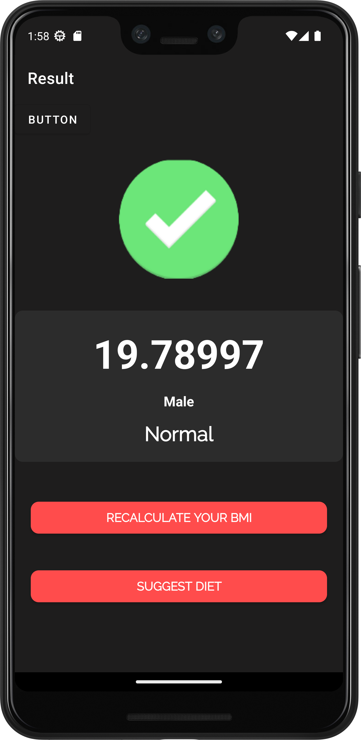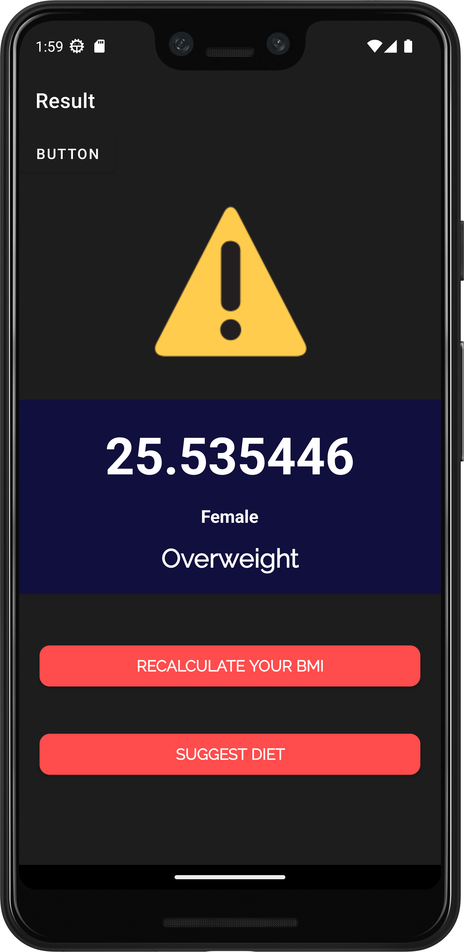

**Fig 6.3: Landing Page Screen 1 Fig 6.4: Landing Page Screen 2**

Fig 6.3 refers to landing page screen 1 when user give inputs as per preferences & show the result normal will come as an output (Male) .Fig 6.4 refers to landing page screen 2 when user give inputs as per preferences & show the result overweight will come as an output (Female).

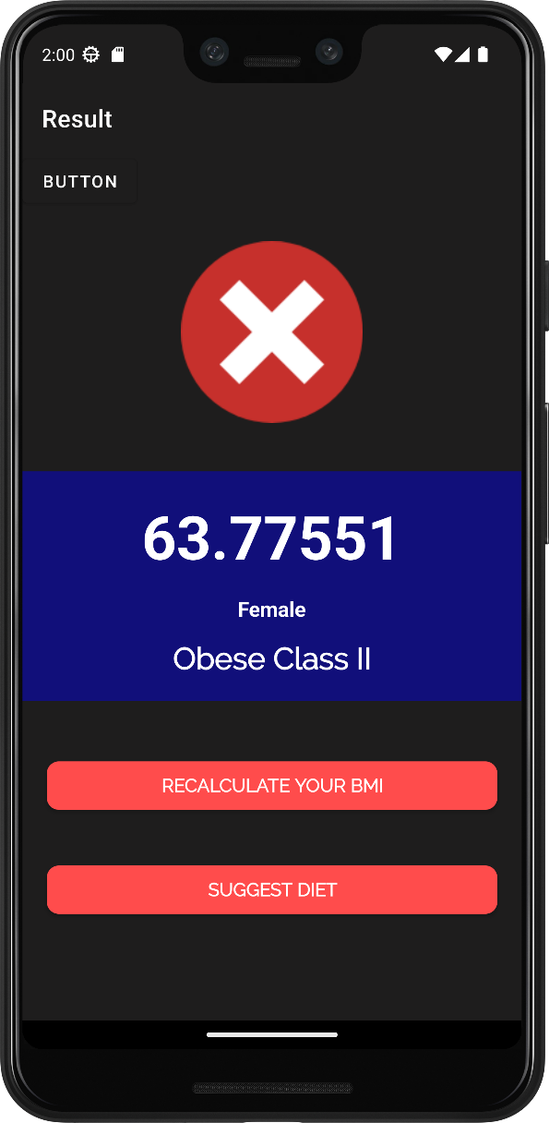

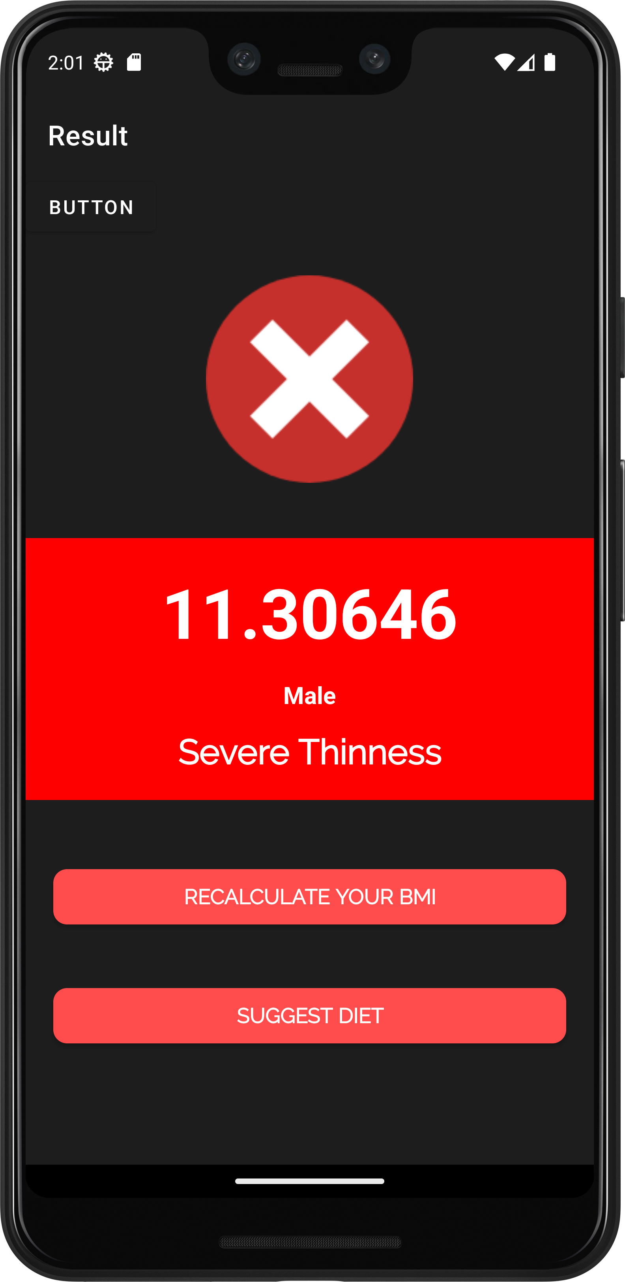

**Fig 6.5: Landing Page Screen 3 Fig 6.6: Landing Page Screen 4**

Fig 6.5 refers to landing page screen 3 when user give inputs as per preferences & show the result Obese Class II will come as a output (Female) .Fig 6.6 refers to landing page screen 4 when user give inputs as per preferences & show the result Severe Thinness will come as a output (Male).

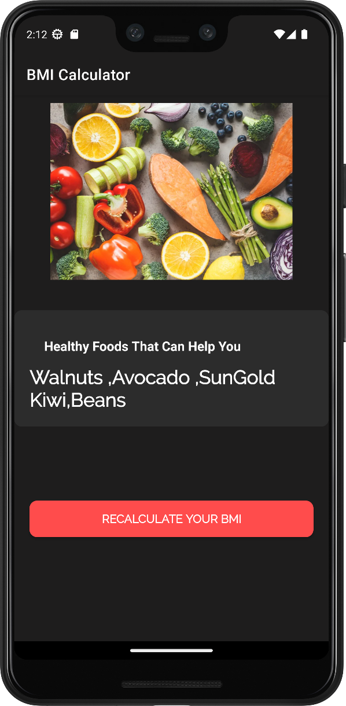

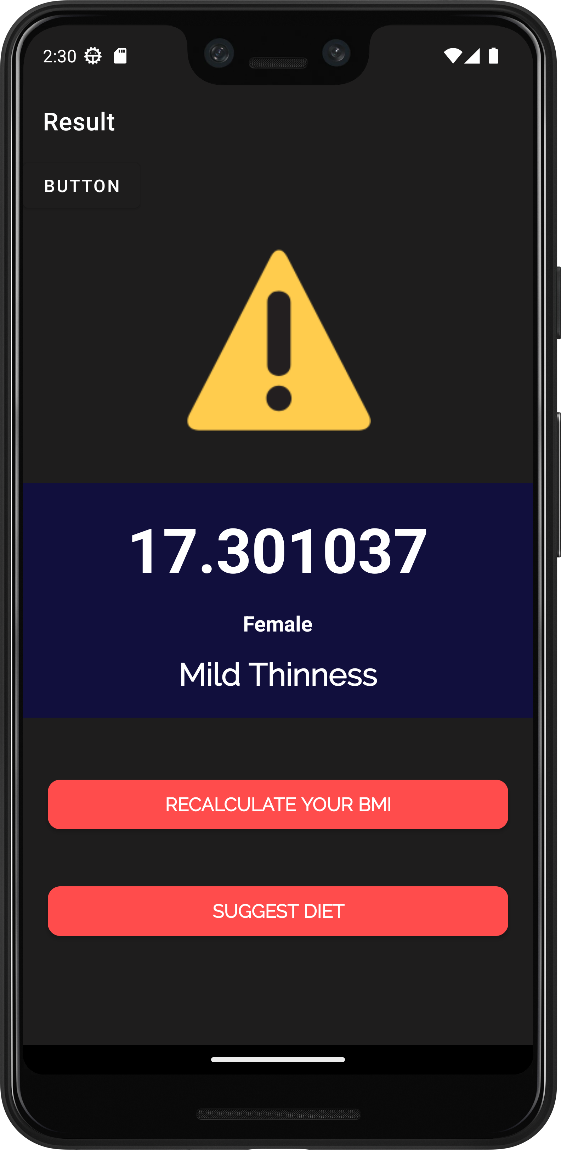

**Fig 6.7: Landing Page Screen 5 Fig 6.8: Landing Page Screen 6**

Fig 6.7 refers to landing page screen 5 when user give inputs as per preferences & show the result Mild Thinness will come as a output (Male) .Fig 6.8 refers to landing page screen 6 when user give inputs as per preferences & give the suggestion of meals according to body weight.

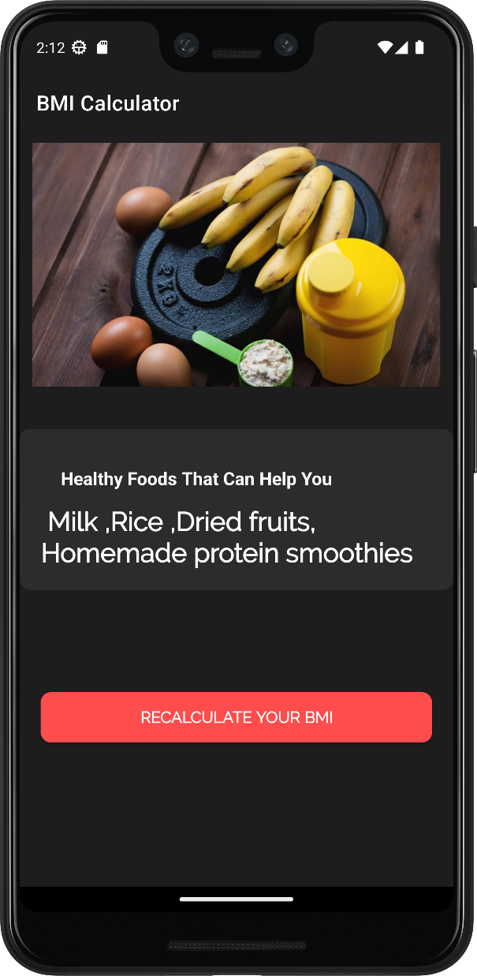 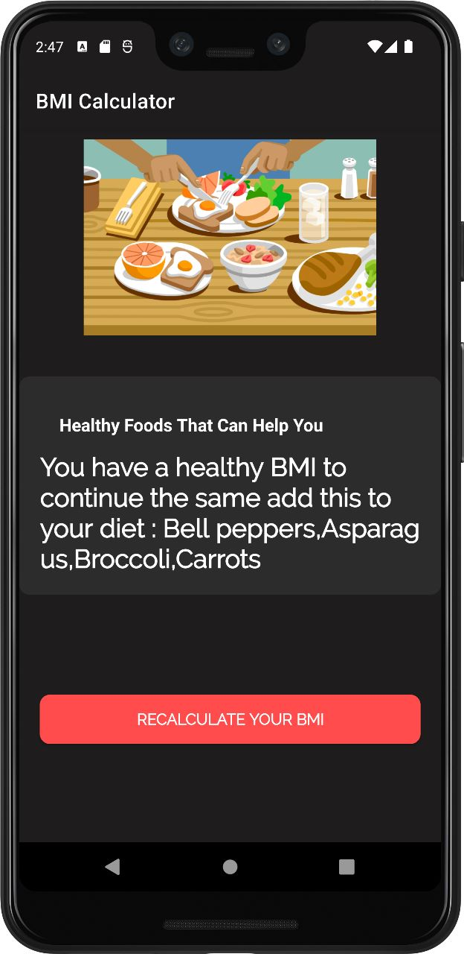

**Fig 6.9: Landing Page Screen 7 Fig 6.10: Landing Page Screen 8**

Fig 6.9 refers to landing page screen 7 when user give inputs as per preferences & give the suggestion of meals according to body weight. Fig 6.10 refers to landing page screen 8 when user give inputs as per preferences & give the suggestion of meals according to body weight.

**CHAPTER 7**

**CONCLUSION**

In conclusion, a BMI (Body Mass Index) calculator is a valuable tool for individuals to assess their weight status and gain insights into potential health risks associated with weight. By calculating BMI based on height and weight measurements, individuals can determine whether they are underweight, have a normal weight, are overweight, or fall into the obese category. This information serves as a reference point for evaluating weight status and can guide individuals towards adopting healthier lifestyle choices. The BMI calculator not only provides a numerical measure but also offers weight classification categories, allowing users to better understand their weight status in relation to health risks. Additionally, the calculator can serve as a motivational tool by encouraging individuals to set and monitor their weight management goals. It raises awareness about the importance of maintaining a healthy weight and can initiate discussions with healthcare professionals for further guidance. However, it is crucial to remember that the BMI calculator is just one component of a comprehensive health assessment and should be interpreted alongside other factors such as body composition, muscle mass, and overall health.

Moreover, Android Studio allows for seamless integration with other technologies and APIs, enabling developers to incorporate additional functionalities like social media sharing, bookmarking, and search options. This enhances the app's usability and provides users with more ways to interact with and share news content. Furthermore, Android Studio offers robust tools for performance optimization and bug fixing, ensuring that the news app runs smoothly and efficiently on a wide range of Android devices. This improves the user experience and minimizes any potential issues or crashes.

**REFERENCES**

**Textbooks:**

* Android Developer Fundamentals Course – Concept Reference

**Websites:**

* <https://developer.android.com/studio/projects>
* <https://www.javatpoint.com/android-tutorial>
* <https://www.geeksforgeeks.org/body-mass-index-calculator-in-android-studio/>